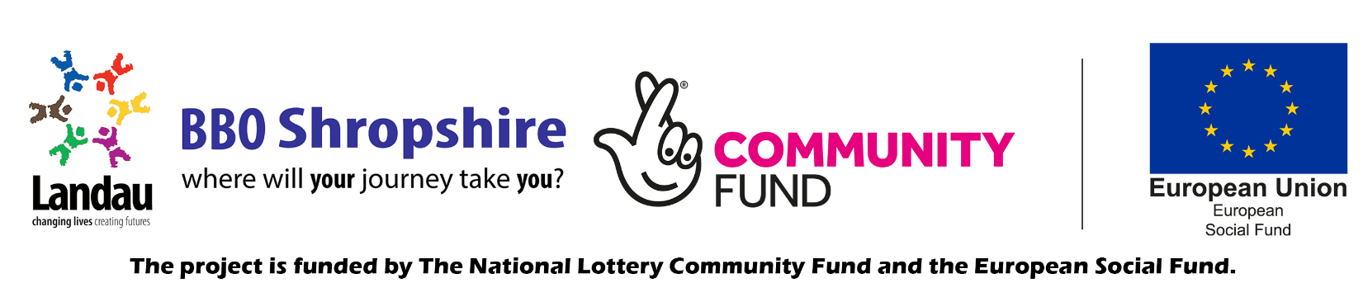
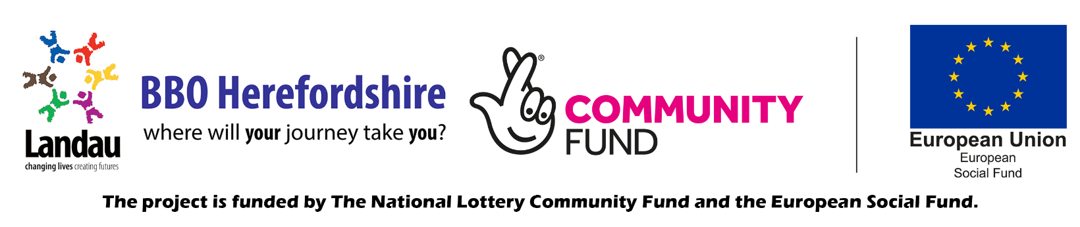

Job Description

Job title: | Quality Assurance Manager
Location: | Home/ Office based
Responsible to: | Head of Quality Assurance
Responsible For: | Leading the Quality Assurance Team (QAT) to ensure Landau remains compliant with all contracts delivered.  Leading the QAT to ensure all contracts are using our in-house CRM system, developing and providing business and project reports.  Playing a pivotal role in the integration and embedding of Quality Assurance and Data Collection of new contracts.  Ensuring processes are created and embedded to support in consistently delivering Quality and Best Practice across the business.

Job purpose

Responsible for providing business and project reports in order to ensure effective, efficient and accurate statistics for Landau the project.
To work with the QA team and Landau delivery teams to ensure all contracts are using Cognisoft and that the correct capture of data required can be extracted and used for reporting

Lead upon ensuring the overall quality assurance for all contracts across Landau. Support the team to develop a comprehensive understanding and working knowledge of Landau contracts.

Lead the team to continuously monitor and review process to ensure compliance remains at a high quality. Proactively identify shortfalls and implement improvements to policy and processes to support with efficiency and quality assurance.

Effectively motivate, manage and mentor the Quality Assurance Team (QAT) ensuring consistent and accurate output as per agreed timescales.

Lead and support on quality assurance with partners and internal delivery to ensure the best possible experience for the participants.

This post is part of the Building Better Opportunities programme and part funded by the National Lottery Community Fund and the European Social Fund as part of the 2014-2020 European Structural and Investment Funds Programme in England.

MAIN DUTIES

 | Processing reports which support to review Landau Performance and Quality across the business, including working with Partnership Coordinator to develop reports for BBO partners.
2. | Act as primary escalation for internal and external partners with Cognisoft, periodically.  Train the trainer - train key members of staff/ management to enable them to deliver training on Cogni.
3. | Work with Head of QA and other departmental managers to develop reports that enable performance and quality reporting throughout our contracts  Working with teams to ensure that all existing and new contracts are using Cognisoft
4. | Work with SMT to support with mobilisation plans taking the lead with data management systems.
5. | Lead in the management of Cogni and liaising with the MIS system, to report any issues with the system and produce reports that are fit for purpose
6. | To assist in the preparation of project reviews, reports and project audits as required by the National Lottery Community Fund, European Social Fund, any other third party Funder and Landau.  Assisting and supporting the business during times of audits/ quarter, including moving resources to boost support at these times.
7. | Take the lead on GDPR for the QAT. Keeping abreast of, understanding and communicating GDPR rules and regulation updates (or changes) to Partners and colleagues.  Assisting with the development of internal data controls and procedures, Keeping a GDPR register of data stored on MIS
8. | Work with the Head of QA and team leader to support and organise the department through audits
9. | Support on the delivery of Quality Assurance (QA) across all projects, ensuring that the QAT has a thorough understanding of the terms of the contract requirements.  Support the QAT in supporting Key Landau staff members to develop a thorough understanding of the contractual requirements of their programs
10. | Support in devising and implementing QA processes throughout the business which will support with the monitoring of QA, consistency of quality service and best practice.  Including reviewing and devising appropriate reports which support in this task.
11 | To lead in working collaboratively with external and internal delivery partners to continually review and improve systems and procedures that meet the needs of the funders, always ensuring the delivery of a high quality and compliance services.  This will include creating, reviewing & assessing the key delivery plans for both internal and external delivery providers.  To schedule quality/spot checks with internal and external partners, consisting of planned and unplanned checks to monitor partner delivery for quality and conducted as outlined and mutually agreed in the plan.
12 | To lead the team in remaining up to date with any changes to compliance, QA for all contracts, implementing quickly any changes in guidance.
13. | To represent Landau and the QA team at appropriate local, regional and national events and meetings as required. Always promoting Landau in a positive and professional manner.
14. | Work with Head of QA and QA Manager to deliver effective Team appraisals and feedback.  Support and encourage the team with the development and acquisition of new skills and knowledge in line with the changing needs of the role and the business.
15 | Attend and contribute to regular performance review as and when required as set out in the staff handbook.  Take responsibility for own personal development and acquisition of new skills and knowledge in line with the changing needs of the role and the Business.

Post holder may be required from time to time to undertake other duties, not specifically mentioned in this job description, but within levels of their salary scale. On occasion there may be travel and work in unsocial hours.

Prepared By: | Nicki Ulloa
Date: | April 2021

The Company reserves the right to vary or amend the duties and responsibilities of the post holder at any time according to the needs of the Company’s business.

Person Specification

(E = Essential, D = Desirable)

Skills and Core Competencies
Technical competency (qualifications and training)

- Must have at least 3 years’ experience in a similar role and hold or be working towards a recognised qualification (E)
- Trained to a Designated GDPR lead or be willing to train towards (E)

Experience

- Minimum of 3 experience of working in a Quality Assurance role (E)
- Experience in managing Cognisoft the CRM system (E)
- Experience in data collection/ analysing (E)
- Experience of partnership working and integration with key agencies, negotiation and liaison work with other agencies. (E)
- Relevant previous experience working on funded provision (The National Lottery Community, ESF, ACL, SFA, DWP). (E)
- Experience of managing and leading a team. (D)
- Experience in reviewing and developing processes. (D)
- Experience of delivering training. (D)
- Experience in project management (D)

Knowledge

- A high level of understanding in the principles and practice of Quality Assurance (E)
- A high level of understanding in CMR systems and data collection (E)
- Knowledge of stakeholders and how to engage with partners to develop strong partnerships and to help with business growth (E)
- Must be competent in Microsoft applications e.g. Excel, SQL reporting and ideally some experience of Yeti. (E)
- Confident in using CRM systems and developing reports (E)
- Knowledge and understanding of key work place policies and procedures (D)

Competencies & Skills

Communication skills: Use your communication skills to set rules, contractual requirements, define employee roles, encourage employees to take their own decisions, and obtain goals for your teams. Your will use your communication skills to increase morale, productivity, and team unity easily and effectively. You will lead the team to persuade and influence face-to-face (virtually) and through a range of media including presentations. Ability to engage confidently and sensitively with stakeholders and partners at a range of levels of seniority.

Emotional Intelligence: The capacity to recognize your own feelings and those of others, and to manage emotions effectively in ourselves and our relationships. Self-Awareness. Self-Management. Social Awareness. Relationship Management.

Interpersonal Skills: High level of optimism, initiative and effective interpersonal skills in order to engage effectively with colleagues, partners and stakeholders. An understanding of Disability Capability, empathy and belief in the potential of people with differing needs.

Conflict Management: Helping colleagues to avoid or resolve interpersonal conflicts. Leaders are often called upon to adjudicate when members are in conflict, but it also involves having the ability to either avoid or resolve your own conflict situations.

Influencing and negotiating skills: Sales skills to promote learners to employers to secure programme outcomes. Ability to encourage, persuade and motivate at all levels. You are clear on our employer offer. Develop your network of employers to produce job opportunities for clients, job carving for participants across Landau.

Completing partner QA action plans: Accurate identification of partner’s non adherence to contractual obligations or lack of quality of service. Able to proactively and collaboratively devise an action plan with inventions delivered by self, or sourced through additional support network to help support, mentor and monitor progress.
Experience of people development on a one to one and group basis. Customer focused with a strong commitment to client care.

Project management: You will apply the application of processes, methods, skills, knowledge and experience to achieve specific project objectives according to the project acceptance criteria within agreed parameters. Delivering on final deliverables to a constrained and finite timescale.

Adaptable and flexible: To be able to work across different contracts within Landau in a compliant and productive manner. Ability to cope with a variety of challenging situations in a calm and sensitive manner. Able to work flexible hours and travel through prior arrangement as the needs of the job dictate.

Networking: An ability to establish, nurture, and cement working relationships, coalitions, and partnerships, both inside and outside the organization.

Commercial Awareness: Knowledge and interest in education and employability. You have a clear understandings of how Landau works across the business. You remain up-to-date with your industry and business in general. This includes marketing trends, customer demographics, technical advances, and the successes and failures of competitors.

Results Orientated and Managing Performance: Focused on your goals and understand the steps needed to achieve them. The motivation to see projects through to fruition and motivate others to do the same. Understanding exactly what your performance targets are, and how you will achieve these. Whilst also being ambitious enough to increase performance and to support others in doing so.

Resilience: An ability to perform effectively even under pressure and/or in the face of setbacks and opposition.

Problem Solving: You are able to stay calm under pressure, research possible causes, identify trends and choose the most relevant solution. Creative problem solving skills and a positive approach to challenging and overcoming limiting beliefs

Self-management: The ability to prioritize goals, decide what must be done, and be accountable to complete the necessary actions. Quality self-management is extremely important particularly as elements of your role are completed remotely.

Decision-Making: One of the core competencies for leaders is the ability to make good decisions or lead a good decision-making process. There are better and worse ways to make decisions, and a good leader understands when to make a decision, when to consult subordinates or peers and bring them into the decision-making process, and when it’s time to step back and let others decide.
Attention to detail: To have an excellent understanding of paperwork and compliance required of your contract. The ability to work to a defined delivery structure. Proficient in using information technology systems (Cognisoft, Microsoft, CRM etc.) Experience of keeping manual and computerised records. Understand the importance of recording data to evidence for fidelity and other contractual requirements.

Trustworthiness & Ethics: You are a trustworthy person and aligned with the ethics of Landau.
You believe in our vision that, every disabled and disadvantaged person has the opportunity to work and fulfil their potential. You will build relationships with existing staff members and enhance team working efforts.

Safeguarding

- Be able to display an awareness, understanding and commitment to the protection and safeguarding of young people and vulnerable adults. (E)

- This post requires a Disclosure & Barring Service (DBS) disclosure at an Enhanced level. (E)

Other
- Have an understanding of and be able to demonstrate a commitment to Equal Opportunities and Diversity. (E)
- Flexibility to travel within the region. (E)
- Flexibility to working out of ‘normal office’ hours. (E)
- Full and current driving licence (for rural and remote regions). (E)
- Lived experience. (D)

As well as possessing the necessary qualifications, skills, knowledge or experience, having the right mind-set and behaviours which are in line with our company values is equally important

